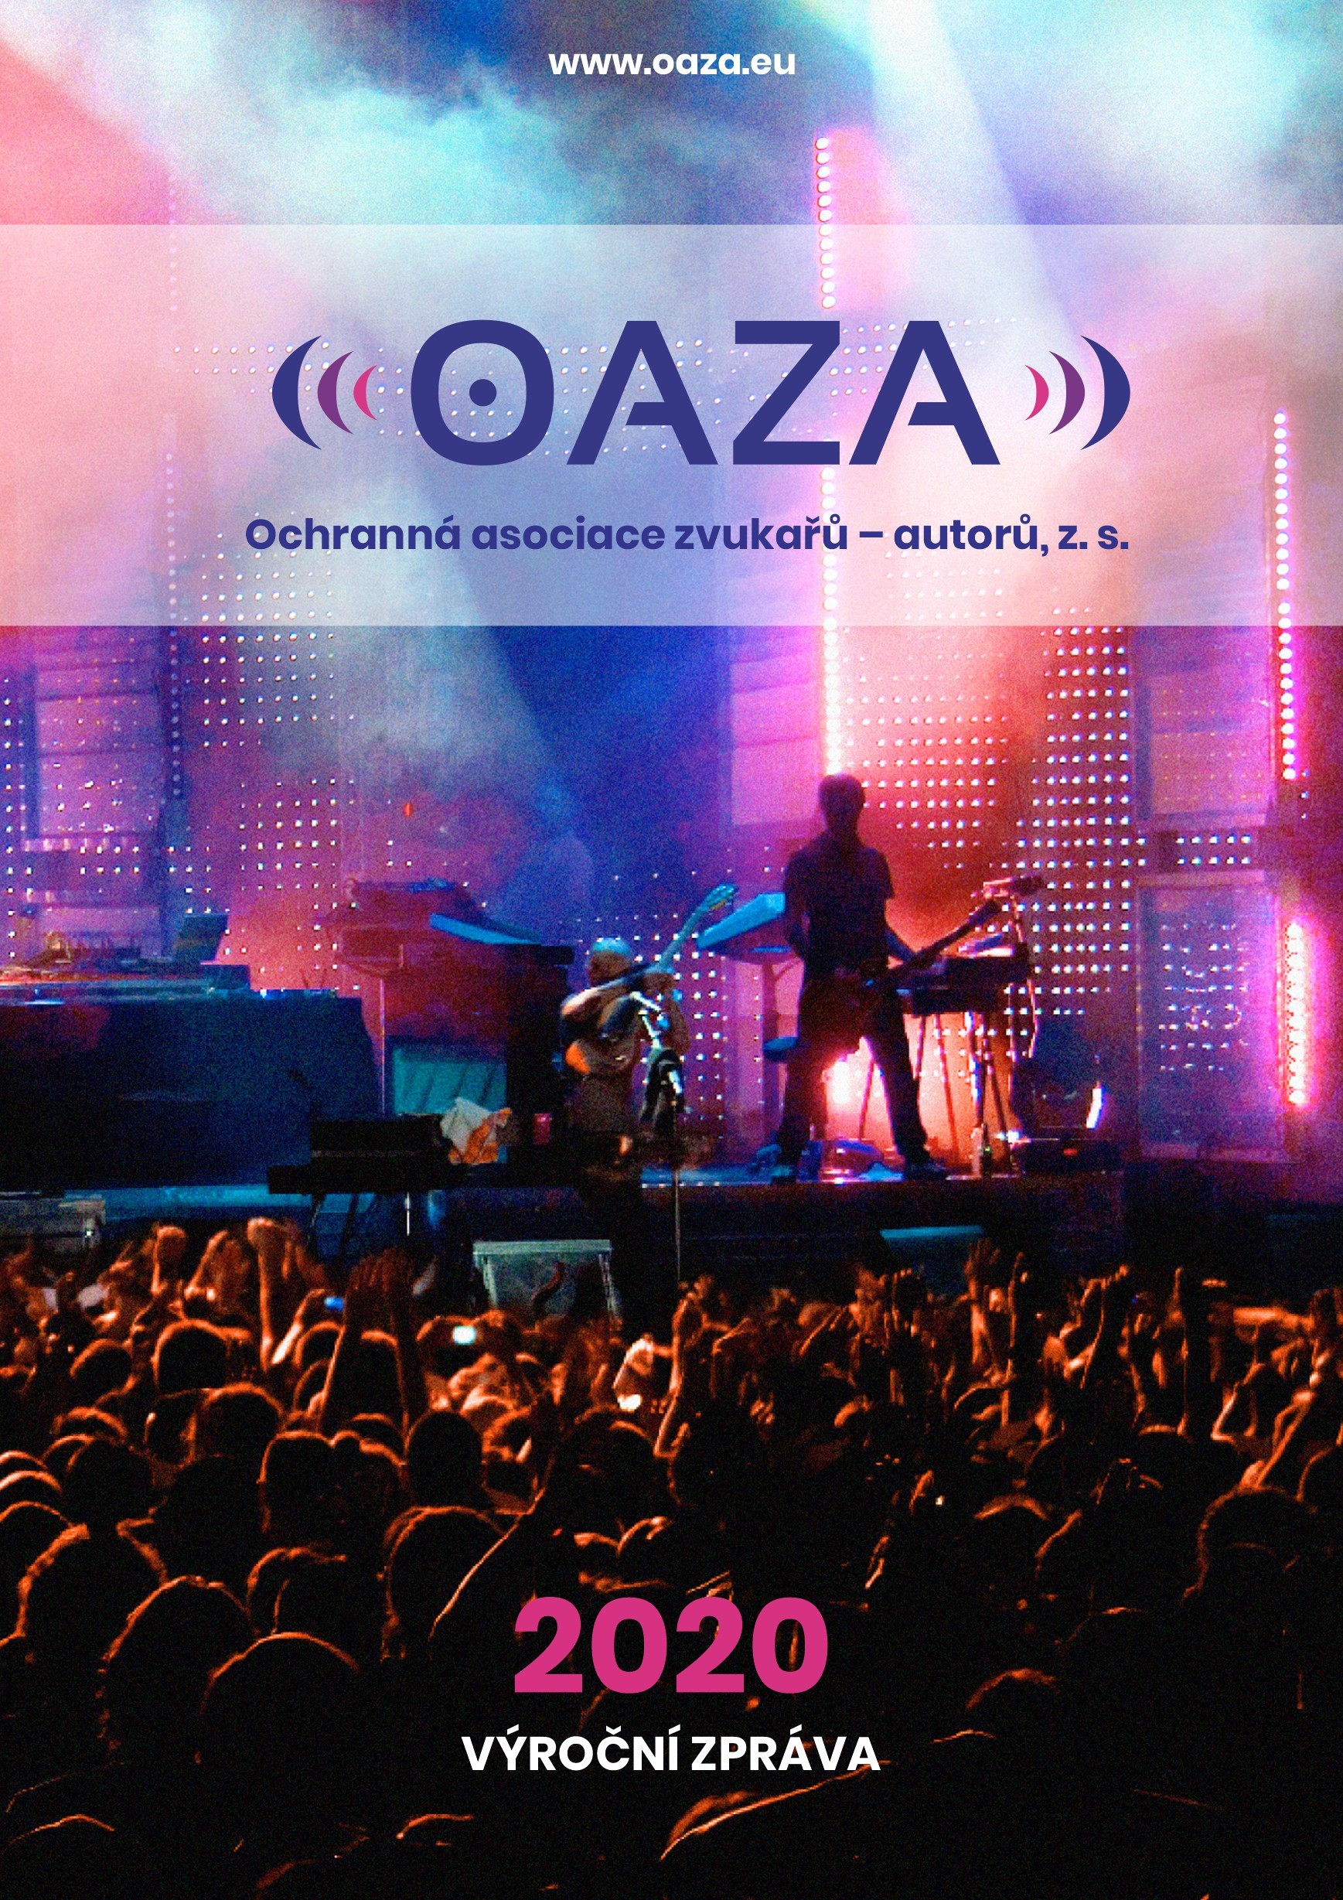
OAZA 2020 ANNUAL REPORT
Contents
INITIAL INFORMATION 2
Financial Statements in accordance with the Accounting Act and the Cash Flow Statement 2
Report on the activities carried out during the accounting period 2
Information regarding cases of refusals to grant a license under Section 98 par. 1 of the Copyright Act 5
Description of the legal form and the management system of the collective administrator 5
Statutes 7
Bodies of the association 7
Board of Directors: 8
Supervisory Board: 8
Author Committee: 8
Represented holders of rights 9
Authorization to perform the collective administration 9
Distributional Rules 10
Information regarding all entities in which the collective administrator holds a property interest or which the collective administrator directly or indirectly, completely or partially controls 12
Information regarding the total amount of remuneration paid to people who perform supervisory functions and people who manage the collective administrator, and regarding any other benefits which were provided to them during the previous year. 12
FINANCIAL INFORMATION 13
Information on the total amount of income arising from the performance of the rights based on the category of the administered rights and the manner of using it, including information regarding investing the income from the performance of rights and regarding the use of such income 13
Information on the amount of expenses for the administration of rights and other services provided by the collective administrator to the holders of rights: 14
Financial information regarding the amounts belonging to the holders of rights 15
Information regarding the relations with other collective administrators 17
FURTHER INFORMATION (Special rights regarding the use of amounts deduced for the purposes of provided social, cultural and educational services) 17
The amount deduced for the purposes of paying expenses arising from the provision of social, cultural and educational services during the given accounting period and the specification of individual purposes, and individual categories of administered rights for each purpose 17
Information on the use of such amounts with the distribution based on the purpose for which they were used 18

INITIAL INFORMATION

Financial Statements in accordance with the Accounting Act and the Cash Flow Statement
The Financial Statements form Annex No. 1 to this OAZA 2020 Annual Report.

Report on the activities carried out during the accounting period
- With effect starting on 1 January 2018, the collective administrators of OAZA and Integram concluded an agreement on the authorization to perform collective administration through which Integram had authorized the OSA collective administrator to conclude licensing agreements and to collect author remuneration for the use in the form of providing radio and television broadcasting (Section 23 of the Copyright Act) and of performing operation from the record (Section 20 of the Copyright Act) for Integram and OAZA. Given the fact that similar contracts have been concluded by other collective administrators, the OSA collective administrator became the only collection point for the users of protected works in the form of providing television or radio broadcasting and by performing operation from the record. The agreement ensures the transparency of collecting remuneration and most importantly provides a guarantee for the users that the copyrights would be resolved in the form of a single agreement and by performing a single payment.
- Ever since 2017, the OAZA collective administrator have been intensively conducting negotiations with the operators of broadcast transmissions, specifically on the basis of their objections filed against the price list in the field of transmitting broadcasts. The negotiations have partially resulted in a success in September of 2019 when the agreement with the Czech Chamber of Commerce was signed, since it unifies the majority of the market of the so-called cable operators, the so-called users of protected works in the form of providing television or radio broadcasting under Section 22 of the Copyright Act. Given this general framework agreement, the collective administrator had managed to secure contracts with practically the entire market of cable operators, while the agreements were concluded for the period from 1 January 2020 to 31 December 2023.
- Every year, the OAZA collective administrator negotiates not only with legal entities unifying a higher than negligible number of users of protected copyrighter works, such as AHR (Association of Hotels and Restaurants), HKČR (Czech Chamber of Commerce), etc., but also directly with the users, mainly in the field of using their own broadcasting and transmitting a broadcast under Sections 21 and 22 of the Copyright Act. These negotiations have been concluded for the purposes to of negotiating a collective agreement, i.e. the agreement between the collective administrator and a legal entity unifying the users, or to conclude a licensing agreement directly with the user of protected works. Even though the field of transmitting a broadcast represents the mandatory collective administration and in the field of broadcasting by radio itself the extended administration, the OAZA considers it to be very important to work on the system of monitoring the use of represented right owners, both in the fields of audio-video and audio.
- Unfortunately, there still hasn’t been any success in concluding licensing agreements with operators of transmission in any other manner than by the use of cables, i.e. especially with the so-called satellite operators. Although they use the protected works in the same manner as cable television operators, but they have only chosen a different technology, they refuse to pay the remuneration to the authors for the use of their works.
- The OAZA participated in a mediation negotiation with the representatives of associations unifying radio broadcasters and the Czech Radio. These negotiations have been suspended due to the measures taken during the emergency situations in the Czech Republic.
- Within the statutory period, the collective administrator had prepared the Price Lists for the year of 2021. The compiled proposals have properly been submitted to the Ministry of Culture of the Czech Republic by 31 August 2020, accompanies by their rationale for approval, published at the OAZA’s website and delivered to legal entities which had filed their applications as the representatives of not-negligible number of users. The Price Lists have only been increased by the inflationary rate of 2020. In relation to the proposals of the Price Lists, the OAZA had received seven objections and proceeds in negotiating with the given associations of users.
Since 2016, the collective administrator had concluded twenty-three reciprocal contracts, 4 of which were concluded in 2020. These include the following partnership collective administrators:

ALBAUTOR  Albania | CPRA/GEIDANKYO  Japan | RSAU  Rwanda
ANCO  Moldavia | DGK  South Korea | SADIA  Angola
ARMA-UKRAINE  Ukraine | ECCO  Eastern Caribbean Region | SUISSIMAGE  Switzerland
AZDG  Azerbaijan | ECCO – Eastern Caribbean Region – Commonwealth | SUISSIMAGE  Lichtenstein
BSCAP  Belize | GERA  Georgia | UARA  Ukraine
COPYDA  Denmark | ISOCRATIS  Greece | ZAPA  Poland
COSCAP  Barbados | KOPIOSTO  Finland | ZIMURA  Zimbabwe
COTT  Trinidad a Tobago | NORWACO  Norway

As for its foreign policies, the OAZA collective administrator had been attempting to obtain the status of a proper member of CISAC which is an international confederation of associations of authors and composers unifying collective administrators within a social network of 232 members from 121 countries from all over the world.
The collective administrator has actively been communicating the National Fund of Cinematography. This fund has been completely forgetting the author group of sound engineers when distributing the remuneration, despite the fact that it had ordered a compilation of an expert report which had confirmed the creative contribution of sound engineers in audio-visual works with which the National Fund of Cinematography had been operating. The National Fund of Cinematography administers property rights to older Czech movies which were created in the Barrandov Movie Studio and the Zlín Movie Studio between 1965-1991. A part of the remuneration which the fund obtains on the basis of commercial use of these movies is distributed to the holders of rights via individual collective administrators. Even though the sound engineers have been recognized as authors by both a court ruling and the Ministry of Culture more than 13 years ago, the National Fund of Cinematography keeps to negotiate with the sound engineers in a serious manner and send the renumeration for them to the OAZA collective administrator.
In 2020, the collective administrator had been interested in the draft of an amendment to the Copyright Act compiled by the Ministry of Culture of the Czech Republic. The OAZA sent its objections as part of the multi-department objection proceedings together with the partners.
When it comes to its own Social Fund, the collective administrator had distributed within the internal social program for is members the contribution in the amount of CZK 5,000 in the spring and winter of 2020 during the emergency situation. 23 members of OAZA had applied for this contribution and this entire event was aiming at supporting the members during the governmental anti-epidemic restrictions.
In 2020, the OAZA collective administrator had collected a significantly lower income due to the adverse influence of the coronavirus pandemic in the Czech Republic, because of repeated waves of disease spreading among the population, and mainly due to governmental restrictions disabling the operation of establishments which used reproduced music or which provided television and radio broadcasting. These governmental restrictions led to an economic lockdown and the prohibition or restriction of sale, retail sale and services, such as gastronomic, accommodation, body-care or sporting services. Moreover, the movement of people and their gatherings in one place were also restricted. Therefore, the income of the collective administrator had been decreased significantly.
After the end of the first wave of the crisis caused by the coronavirus pandemic and the end of the emergency situation, the collective administrator requested compensation from the Czech Republic at the beginning of September 2020, by exercising its claim to compensation for damage and satisfaction due to maladministration which led to an extreme decrease in the income of the collective administrator in 2020.

Information regarding cases of refusals to grant a license under Section 98 par. 1 of the Copyright Act
During the accounting period of 2020, there has been no cases of a refusal to grant a license under Section 98 par. 1 of the Copyright Act.

Description of the legal form and the management system of the collective administrator
The protective association of sound engineers – authors (Ochranná asociace zvukařů – autorů, z.s. = OAZA) had been established in 2003 as a professional organization associating sound engineers on the principle of voluntary membership. Since the beginnings of its activities, the OAZA had focused on the protection of rights of this professional group, provided information on the rights and obligations of sound engineers, initiated cooperation with other protective organizations in the Czech Republic. The most important task of OAZA was to compile an application to be submitted to the Ministry of Culture of the Czech Republic on the basis of which the professional group of sound engineers would officially be recognized as an author creative profession, i.e. to manage to arrive at the accordance between the factual situation and the legal situation. This long-term activity has led to a successful defence of the rights of sound engineer at the Municipal Court in Prague in 2005, when it was recognized by a court authority that the sound engineers create arts of works based on meeting the requirements for copyrighted works. As a result of the court’s decision, the Ministry of Culture of the Czech Republic had granted to OAZA under Section 98 AZ on 15 November 2006 the authorization to perform collective administration of rights of people and entities to whom property rights to copyrighted works created by sound engineers belong. The given authorization came into effect on 20 November 2006 and since then, OAZA have been acting as the collective administrator of property copyright of sound engineers.
Since the beginning of its activities in the field of collective administration of property rights of sound engineers, the collective administrator intended and still intends to perform all the rights which had been granted to it by the authorization. The realization of the majority of such rights required rather long preparations, specifically legal and economic analyses and surveys of the actual market, obtaining a strong base of represented holders of rights and works which are used in this field. At the beginning, it was necessary to initiate the collective administration in the field of mandatory and quasi-mandatory collective administration in order that the represented holders of rights realized that the collective administration represents an effective and meaningful measure. The commencement of the execution of the so-called voluntary collective administration required not only a strong base of Czech contractually represented holders of rights, but also the conclusion of relevant reciprocal agreements with foreign collective administrators in order that the collective administrator was able to act on behalf of both domestic and foreign holders of rights while negotiating author remunerations and concluding agreements. Due to administrative proceedings conducted by the Ministry of Culture of the Czech Republic which lasted for several years and which led to authoritative interventions against the OAZA Price List, the process of acquiring new represented holders of rights and particularly negotiating with other collective administrators and obtaining foreign cooperation became significantly and artificially slower. The collective administration of property copyrights of sound engineers had been very overlooked also in the past all over the world; therefore, the sound engineers abroad are only receiving protection of their rights, just as it has been happening in the Czech Republic, in a very gradual manner. Only since 2016, the OAZA collective administrator initiated cooperation with foreign collective administrators, and by 31 December 2020, it had concluded 23 reciprocal agreements. The increasing prestige of sound engineers worldwide may also be proven by the fact that the OAZA had became an associated member of the CISAC organization, the International Confederation of Societies of Authors and Composers, which represents more than 4 million creators from all over the world and artistic repertoires: music, audio-vision, theatre, literature and fine art. The CISAC unifies 239 collective administrators from 121 countries of the world.

Statutes
The fundamental and main mission of the OAZA is to perform publicly beneficial activities while protecting and administrating the rights of sound creators – authors (the so-called sound engineers) as a protective author organization – a collective administrator in accordance with Act No. 121/2000 Coll., on copyright, on rights related to copyright and on the changes of certain acts (hereinafter the Copyright Act), as amended by subsequent legislation, related acts and international copyright treaties as well as other international treaties by which the Czech Republic is bound.
However, the OAZA is performing also other purposes of its activities, mainly the informational and educational activities, motivation and support of young and talented people in the field of sound creation and other related fields, cooperation with professional organizations and associations of authors, scientific and expert institutions, colleges and universities, and other cultural institutions and workers in the field of culture, organizing professional courses, trainings and other educational events including lecturing activities, activities of informational and news agencies, activities of social support for authors and other holders of rights.
As the main subject of its activities, the OAZA ensures and performs the protection and administration of copyrights on the basis of an authorization to perform collective administration granted by the Ministry of Culture of the Czech Republic, doing so continuously, in its own name, at its own responsibility and within the extent of agreements on representation during the performance of copyright, concluded with authors or inheritors of copyrights, or other holders or acquirors of these rights.
The OAZA is entitled to protect the rights of represented authors and holders of copyrights even outside the territory of the Czech Republic, especially on the basis of bilateral contracts concluded with foreign partner organizations, ensuring mutual reciprocity during their execution. The OAZA is entitled to operate at the territory of the Czech Republic and of other countries, especially the member states of the European Union or countries forming the European Economic Area, without any limitation.

Bodies of the association
The bodies of the registered association of OAZA consist of the General Meeting, the Board of Directors and the Supervisory Board. The working bodies of the organization which had been established in accordance with internal regulations of the association are expert commissions in particular.
The General Meeting is the highest body of the OAZA. It adopts decisions regarding all important matters related to the activities of the association. The annual General Meeting takes place at least once a year. The General Meeting cannot take place in the form of partial meetings. The scope of activities entrusted to the General Meeting cannot be performed by the Assembly of Delegates. The General Meeting is convened by the Board of Directors of the OAZA no less than 4 weeks in advance by delivering an invitation to the members of the association or by another provable manner of informing them about the General Meeting to be held. The Board of Directors shall convene the General Meeting when at least 2/5 of its members request so. In such a case, the General Meeting shall gather within the next 60 days. If the Board of Directors fails to do so, the Supervisory Board shall proceed in the matter. The General Meeting forms a quorum if more than half of the members gather at the selected hour. Its decision is adopted if more than half of the members present vote in favour of it.
The Board of Directors shall act on behalf of the association as its statutory body. The Board of Directors adopts decisions and resolutions in the matters which are not expressly entrusted in the General Meeting, or in the matters and fields which the General Meeting entrusted in or ordered to perform to the Board of Directors. The Board of Directors shall consist of at least three members and its term of office lasts five years. The details regarding the election of the members of the Board of Directors may be specified by the Rules of Procedure or the Organizational Rules. It is permitted to become a member of the Board of Directors repeatedly.
The Supervisory Board consists of at least three members and represents a supervisory and arbitral body of the association (within the meaning of Sections 262 and 265 of Act No. 89/2012 Coll., Civil Code, as amended). The members of the Supervisory Board are elected by the General Meeting and the term of their office lasts five years. The membership in the Supervisory Board excludes the possibility to be a member of the Board Directors. The details regarding the election of the members of the Supervisory Board shall be specified by the Rules of Procedure.

During the calendar period of 2020, the bodies of the OAZA association had the following members:

Board of Directors:
Chairman | Jaroš Karel, prof., Ing.
Deputy Chairman | Štěpánek Jiří
Member | Jína Robert

Supervisory Board:
Chairman | Ulm Karel, Mgr.
Member | Babický Martin, Ing.
Member | Greiner Ladislav, MgA.

Author Committee:
Chairman | Špalj Ivo, Ing.
Member | Skall Vladimír, Mgr.
Member | Štěpánek Jiří
Member | Jína Robert
 | Pekárek Michal

Represented holders of rights
The right to ask the protective organization for representation belongs to every holder of rights to works created by the sound engineers, i.e. the person which holds property copyright or the performance of property rights to a work under the Copyright Act, or is exclusively entitled to perform the rights collectively administered for the duration of a contract for the entire period of the property rights and at least for the territory of the Czech Republic with the right to provide a sub-license. As of 31 December 2020, the OAZA collective administrator had represented 707 sound engineers in total on the basis of contracts.
The OAZA concludes with the holder of the rights an Agreement on Representation of Property Copyrights which handles the contractual relationship between the collective administrator and the holder of rights. In accordance with the Copyright Act, the collective administration is performed also for the holders of rights which had not concluded such a contract.
The represented holder of rights is obliged to notify the collective administrator without undue delay of the creation of every work, or of a newly acquired right to such a work, namely via a special document issued by the OAZA and titled “Notification regarding a work” in which the holder shall provide all the required details truthfully which are necessary for the performance of the collective administration. The notification regarding of the work may also be performed in an electronic form. The holders of the rights shall perform the notification without undue delay after acquiring the rights. If there is such a need, the holder of the rights is obliged to prove its authorship or to be meeting the statutory requirements for being in possession of the status of the holder of copyrights (e.g. inheritors or employers).
The holder of the rights is entitled to receive billings and payments of remuneration and potential income resulting from an unjust enrichment being handed over. The OAZA enables the holders of rights to inspect the correctness of the amount which had been paid to him/her/it in the form of remuneration or an income resulted from an unjust enrichment. The holder of the rights is obliged to notify the OAZA without undue delay all and any changes of personal details and banking information. These details are confidential and the OAZA is not entitled to use them in conflict with the purpose for which they were provided. The holder of the rights is entitled to access the Annual Report on the activities and economic activities of the OAZA.

Authorization to perform the collective administration
In accordance with the decision of the Ministry of Culture of the Czech Republic dated 15 November 2006, the OAZA performs the collective administration of the following rights within the extent specified in the given decision (in the legal form as of the day when the decision came into force):
Rights administered collectively on a mandatory basis:
- right to remuneration for the creation of a copy of the work for personal needs on the basis of an audio or audio-visual recording by transferring its content by using a device to an empty carrier of such a record under Section 96 par. 1 letter a) point 3 of the Copyright Act; this authorization only includes the distribution of remuneration which had been collected by the OSA collective administrator (Protective Association of Authors) for the rights to works of music and right to use cable transmission of works under Section 97d par. 1 letter c) of the Copyright Act based on the granted authorization;
- right to an adequate remuneration for the lease of an original or a copy of the work recorded in the audio or audio-visual form under Section 96 par. 1 letter b) of the Copyright Act; this authorization only includes the distribution of remuneration which had been collected by the OSA collective administrator (Protective Association of Authors) for the rights to works of music based on the granted authorization

Rights administered collectively on a voluntary basis:

- right to make copies of the works under Section 12 par. 4 letter a) and Section 13 of the Copyright Act;
- right to spread the original or a copy of the work under Section 12 par. 4 letter b) and Section 14 of the Copyright Act;
- right to make the work accessible to the public in the manner that anyone can access it at a place and time of its own decision, especially through a computer or similar network under Section 12 par. 4 letter f) and Section 18 of the Copyright Act;
- right to non-theatrical performance of the work in a live form or through its record and the right to transmit the performance of the work under Section 12 par. 4 letter f) point 1 and Sections 19 and 20 of the Copyright Act;
- right to broadcast the work via radio or television under Section 12 par. 4 letter f) point 2 and Section 21 of the Copyright Act;
- right to operation radio or television broadcasting the work under Section 12 par. 4 letter f) point 4 and Section 23 of the Copyright Act.

Distributional Rules
The key document which specifies the rules for distributing the collected income of the collective administrator are the Distributional Rules which is adopted and approved by the General Meeting of the OAZA. When distributing and paying out the income from the performance of rights and the income resulting from investments of such income (collectively called the income), the collective administrator shall only consider those holders of rights, whose rights to the same protected items or the same types of works are collectively administered on the basis of a contract or who had applied for registration with the collective administrator, while the collective administrator shall not consider the works which had not yet been published. If the collective administrator had collected remuneration for holders of rights which are known to the collective administrator, but are not included in the list of holders of rights registered with it, then it shall invite them to get registered.
The collective administrator shall distribute and pay out the remunerations in accordance with the Distributional Rusel within nine months after the end of the accounting period during which these remunerations were collected, with the exception of a situation when this period could not be met by the collective administrator due to objective reasons. If any remuneration cannot be distributed or paid out within the nine months for the reason of the collective administrator being unable to determine or find such holders of rights, then these remunerations shall be kept separately and used in accordance of rules specified by the General Meeting.
Within three months after the distribution and payment of the remunerations, the collective administrator shall provide access in an adequate manner for the holders of right for whom/which the collective administrator performs the collective administration, and to the collective administrator for whom/which the rights are being administered on the basis of an agreement, to information regarding the works for which one or more holders of rights were not identified. The collective administrator shall adopt all measures necessary to determine or find the holders of rights. No later than within one year after the period under this paragraph, the collective administrator shall publish in an appropriate manner available information regarding the holder of the rights who/which had not been determined or found. If the collective administrator was unable to distribute the remuneration even within three years after the end of the accounting period during which the income had been collected, due to the fact that the holders of the rights were not determined or found, then the General Meeting shall decide regarding the use of such income.
The holders of rights which are not contractually represented by the OAZA and had not applied for registration shall be paid by the OAZA through the reserve fund in the form of a share calculated from the collected remuneration for rights which were mandatorily collectively administered for the period of 3 years going back from the year when the holder of the rights had requested so, and his/her/its share in the collected remuneration had actually emerged, while such holder also concluded an agreement on representation or submitted a subsequent application for registration and provided the OAZA via its official form with the proper notification of his/her/its works which were used, including their use; the collective administration pays the remuneration based on the current amount of the point value based on the Distribution Rules.
In accordance with the Copyright Act, the collective administrator is entitled to request reimbursement of effectively incurred expenses. The amount of such expenses is every year presented by the Board of Directors to the General Meeting and is also included in the Annual Report.

Information regarding all entities in which the collective administrator holds a property interest or which the collective administrator directly or indirectly, completely or partially controls
During the accounting period of 2020, the collective administrator did not hold any property interest in any third party, and did not directly or indirectly, completely or partially control any third party.

Information regarding the total amount of remuneration paid to people who perform supervisory functions and people who manage the collective administrator, and regarding any other benefits which were provided to them during the previous year.

The Board of Directors received remuneration for functions/wages in the total amount of: | 800 809 CZK
The Supervisory Board received remuneration for functions/wages in the total amount of: | 279 008 CZK
The Board of Directors received author remunerations in the total amount of: | 228 322 CZK
The Supervisory Board received author remunerations in the total amount of: | 10 463 CZK
Meal vouchers: | 12 430 CZK
Pension and life insurance: | 26 000 CZK
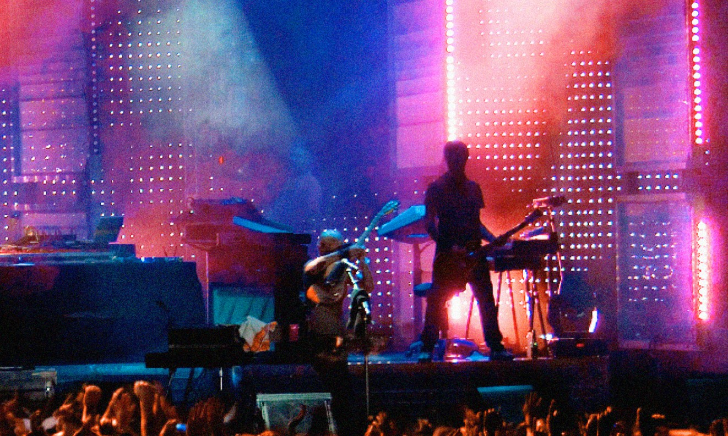

FINANCIAL INFORMATION

Information on the total amount of income arising from the performance of the rights based on the category of the administered rights and the manner of using it, including information regarding investing the income from the performance of rights and regarding the use of such income
During the calendar year of 2020, the OAZA had obtained the remuneration from the total amount of four following rights (rounded to integers of CZK):
- Mandatorily collectively administered right to use cable transmission of works under Section 97 par. 1 letter c), Section 12 par. 4 letter f) point 3 within the extent under Section 22 par. 2 of the Copyright Act
Income arising from this right in 2020 amounted to 6 182 933 CZK

- Voluntarily collectively administered right to operate the radio and television broadcasting of works under Section 12 par. 4 letter f) point 4 and Section 23 of the Copyright Act
Income arising from this right in 2020 amounted to 14 535 693 CZK

- Voluntarily collectively administered right to broadcast the work via the radio or television under Section 12 par. 4 letter f) point 2 and Section 21 of the Copyright Act
Income arising from this right in 2020 amounted to 815 CZK

- Mandatorily collectively administered right to create copies for personal use on the basis of an audio or audio-visual recording by transferring its content via a device to an empty carrier of such a recording under Section 97d par. 2 within the extent of Section 25 of the Copyright Act
Income arising from this right in 2020 amounted to 515 867 CZK
The total income in 2020 amounted to 21 235 308 CZK.

In 2020, the OAZA collective administrator was able to recover the amount of unjust enrichment of 104 521 CZK. The income arising from the unjust enrichment was added to the income from the voluntarily collectively administered right to operate the radio and television broadcasting of works under Section 12 par. 4 letter f) point 4 and Section 23 of the Copyright Act. The income was increased by the income arising from investments in the total amount of 126 370 CZK.

Information on the amount of expenses for the administration of rights and other services provided by the collective administrator to the holders of rights:
Operational and financial expenses with their distribution based on the categories of administered rights and if these are indirect expenses which cannot be included in one or more categories, then also with explanations of a method used to include these indirect expenses
Expenses of OAZA in 2020, rounded to integers of CZK:
Use of material (office equipment, DHIM) 22 475 CZK
Services (IT, monitoring of use, legal services, rent, accounting, translations, phones, audit, etc.) 6 001 285 CZK
Wage expenses, including remunerations for performing functions 2 580 955 CZK
Statutory social security insurance 729 100 CZK
Other social security insurance 100 000 CZK
Statutory social expenses 50 473 CZK
Other taxes and fees 2 798 CZK
Exchange rate losses 10 649 CZK
Banking fees 11 091 CZK
Total expenses of 2020 9 512 267 CZK
In 2020, the OAZA office has minimized the expenses spent for the performance of collective administration. The expenses were equally deduced from the income of each administered right. The OAZA accounted all expenses as indirect and they were distributed by the ratio towards the amount of collection of individual rights.

Operational and financial expenses related to other services than the administration of rights, but including the deductions for the purposes of paying for expenses arising from the provision of social, cultural and educational services
In 2020, the OAZA did not account any operational and financial expenses for the purposes of paying the expenses for the provision of social, cultural and educational services.

Sources used to pay the expenses arising from the administration of rights:
During the accounting year of 2020, the OAZA had paid for the expenses arising from the administration of rights the income arising from the performance of rights and from investments using the income arising from the performance of rights in 2020 in the amount of 7 133 117 CZK. Other sources used to pay for the expenses related to the administration of the rights are as follows: a partial payment from the fund of non-distributable sources in the amount of 1 420 424 CZK, the amount of 1 686 CZK arising from the interest accumulated at the general account, 905 027 CZK from the Reserve Fund back from 2017, and 36 471 CZK from the exchange rate profit. This amounts to totally 9 512 267 Kč, rounded to integers of CZK.
Deductions from the income arising from the performance of rights with specification of categories of administered rights, the manner of use and the purpose of such deduction
During the accounting year of 2020, the OAZA deduced from the income arising from the performance of rights for the purposes of paying the expenses of performing the rights, doing so in the given ratio of each of the performed rights.

Percentage amount of expenses for the administration of rights and other services provided by the collective administrator to the holders of rights in comparison to the percentage amount of income from the performance of rights in the given accounting period, based on the individual categories of administered rights and in the case when the expenses are indirect, which cannot be related to one or more categories, then the explanation of the method used to allot these indirect expenses
During the accounting year of 2020, the collective administrator had incurred expenses for the administration of rights in comparison to the income arising from the performance of rights in the total percentage amount of 44,79 %.

Financial information regarding the amounts belonging to the holders of rights
The total amount allotted to the holders of rights with the distribution based on the categories of administered rights and manners of use
During the accounting year of 2020, the OAZA had allotted to the holders of rights the amount from the collections of performing the rights under Sections 21, 22, 23 and 25 of the Copyright Act in the total amount of income of 13 449 107 CZK, including the distribution of the Reserve Fund from 2016 in the amount of 2 444 485 CZK.

The total amount paid to the holders of rights with the distribution based on the categories of administered rights and manners of use
During the accounting year of 2020, the OAZA had distributed among the represented holders of rights the total amount of 15 075 452.77 CZK coming from the rights administered under Sections 20, 21, 22, 23 and 25 of the Copyright Code. From the given amount, 12 247 162 CZK was distributed from the total amount, while the amount of 466 278,77 CZK from the collection of 2019 and the amount of 18 146 CZK from the collection of 2018. During the accounting year of 2020, the OAZA distributed among the represented holders of rights the amount of 2 247 012 CZK from the Reserve Fund of 2016 and the amount of 115 000 CZK in the form of contributions of 5 000 CZK for its members in the form of internal social challenges of COVID I. and II. during the emergency situation.

The frequency of payments with distribution based on the categories of administered rights and manners of use
During the accounting year of 2020, the OAZA had distributed author remunerations twice and it had met the requirements of the statutory period of no later than on 30 September 2020. All the objections which were found to be justified were paid by 31 December 2020.

The total allotted amount which was not yet distributed to the holders of rights, with distribution based on the administered rights and manners of use and specification of the accounting period during which these amounts were collected
Arising from the income from 2017, the amount still remaining undistributed to the holders of rights equals 1 002 736 CZK. Arising from the income from 2018, the amount still remaining undistributed to the holders of rights equals 2 266 986 CZK. Arising from the income from 2019, the amount still remaining undistributed to the holders of rights equals 1 201 945 CZK and, and from the Reserve Fund of 2019 the amount of 11 192 CZK.

The reasons for delay if the collective administrator failed to distribute and pay to the holders of rights within the period specified in Section 99c par. 2 of the Copyright Act
During the accounting year of 2020, the OAZA performed the distribution and payments within statutory periods, i.e. 30 September 2020. Only in cases of justified objections were the amounts paid by 31 December 2020.

The total amount of non-distributable amounts together with the clarification of the use of these amounts
The OAZA collective administrator had created and its General Meeting approved of the rules for the use of income arising from the performance of rights and the income coming from investments through the income arising from the performance of rights which cannot be paid within the period under Section 99c par. 2 of the Copyright Act due to the fact that the holders of rights could not be determined and found. These amounts of income are kept by the collective administrator separately within its bookkeeping. In 2020, such income amounted to 4 471 667.49 CZK.

Information regarding the relations with other collective administrators
The amounts received by other collective administrators and the amounts paid to other collective administrators with the specification of individual categories of rights and collective administrators
On the basis of the authorization agreement, the OAZA had received from the Integram collective administrator for 2020 the amount of 14 344 867.45 CZK, namely in the form of income from the performance of rights of operating the television and radio broadcasting. The OAZA had received from the OSA collective administrator the amount of 512 781.85 CZK, namely in the form of income for the operation of mandatorily collectively administered rights for the creation of a copy for personal use on the basis of an audio or audio-visual recording by transferring the content by a device to an empty carrier of such a recording.

The reimbursement of expenses for the administration of rights and other deductions from the income arising from the performance of rights payable towards other collective administrators with the specification of individual categories of rights and collective administrators
The OAZA had paid to the Integram collective administrator as the reimbursement of expenses for the administration of rights the amount of 2 531 447.19 CZK and to the OSA collective administrator the amount of 56 975.77 CZK.

The amounts distributed directly to the holders of rights received from other collective administrators with the specification of individual categories of rights and collective administrators
No other collective administrator had distributed remuneration to the holders of rights represented by the OAZA collective administrator.

FURTHER INFORMATION (Special rights regarding the use of amounts deduced for the purposes of provided social, cultural and educational services)

The amount deduced for the purposes of paying expenses arising from the provision of social, cultural and educational services during the given accounting period and the specification of individual purposes, and individual categories of administered rights for each purpose
In 2020, the OAZA had not deduced any financial amount for the purposes of paying expenses for the provision of social, cultural and educational services.

Information on the use of such amounts with the distribution based on the purpose for which they were used
For the accounting year of 2020, the OAZA is not in possession of any such information.
In Prague on 19 April 2021
prof., Ing. Karel Jaroš,
Chairman of the Board of Directors of OAZA, v.r.

